Hospital Dashboard Report

- Executive Summary:
This report analyzes hospital performance across departments, doctors, cities, and time periods. Key metrics include total revenue, patient volume, treatment costs, insurance coverage, and payment mode distribution. The dashboard highlights operational and financial insights to support strategic and operational decisions.

- Key KPIs Overview:
Left-side cards:
- Total Revenue: 93.80M
- Total Patients: 1,500
- Average Treatment Cost: 103.74K
What those mean:
The hospital generated 93.8M in revenue from 1,500 patients with an average treatment cost of 103.74K per patient.

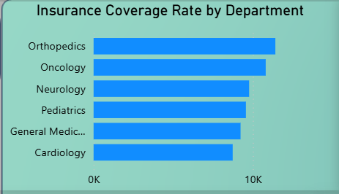
- Department-Level Insights:

- Orthopedics has the highest insurance coverage,
indicating strong insurance penetration.

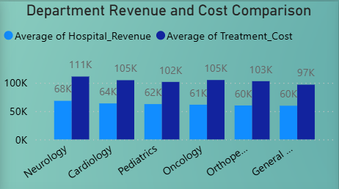

- Neurology and Cardiology generate the highest revenue.

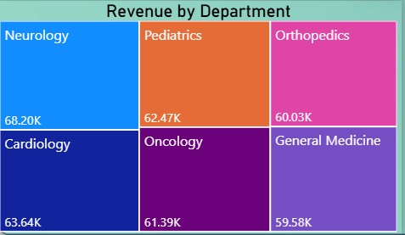

- Oncology shows high treatment cost relative to revenue,
indicating lower margins.

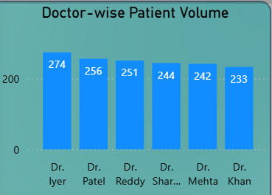
- Doctor Performance Analysis:

Insight:
- Dr. Iyer handles the highest patient volume, indicating higher
workload.
- Patient distribution across doctors is relatively balanced.

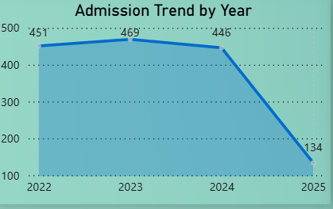
- Time Trend Analysis:

- Admissions peaked in 2023 and dropped sharply in
2025 (data incomplete).

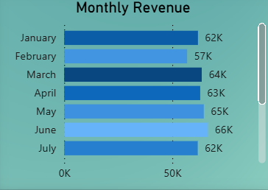
- Monthly revenue shows seasonal variation, with
Sep(69k)–June(66k) highest revenue months.

- City-Level Analysis:
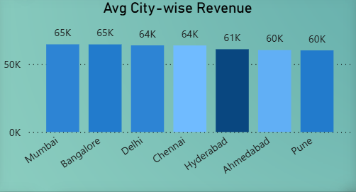

- Bangalore and Mumbai generate highest
average revenue.

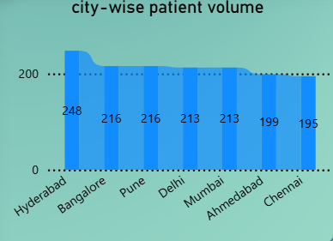

- Hyderabad has the highest patient volume,
indicating operational load.

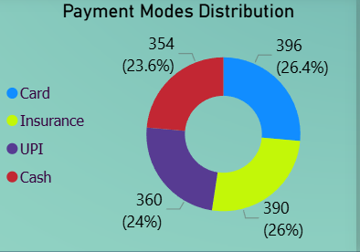
- Payment Mode Analysis:

- Card and Insurance are the most used payment modes.
- Cash usage is declining compared to digital payments.

- Business Recommendations:
• Increase insurance partnerships in low-coverage departments.
• Optimize pricing in Oncology due to high-cost vs revenue gap.
• Allocate more staff to high-volume doctors and cities.
• Focus marketing in high-revenue cities like Bangalore and Mumbai.
• Promote digital payments to reduce cash handling costs.

